Initial user login to Georgia Procurement Registry(GPR) and rest password
Step # | Action
1 | User will get email notification as confirmation for registration with temporary password and link to GPR. User may click on the link to browse GPR site.  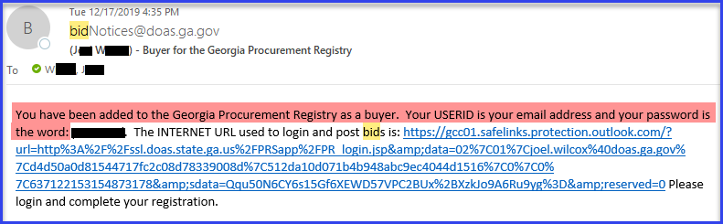
2 | Enter email as user id and temporary password. Click on ‘Login’.  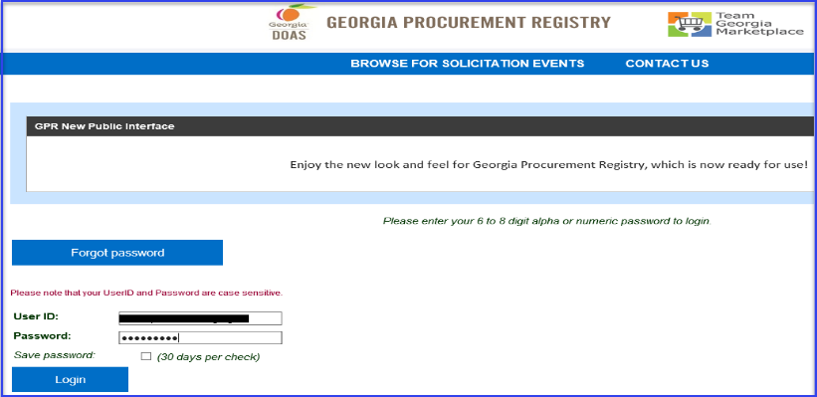
3 | System will take use to ‘Edit Buyer-Procurement Staff Profile’ page.  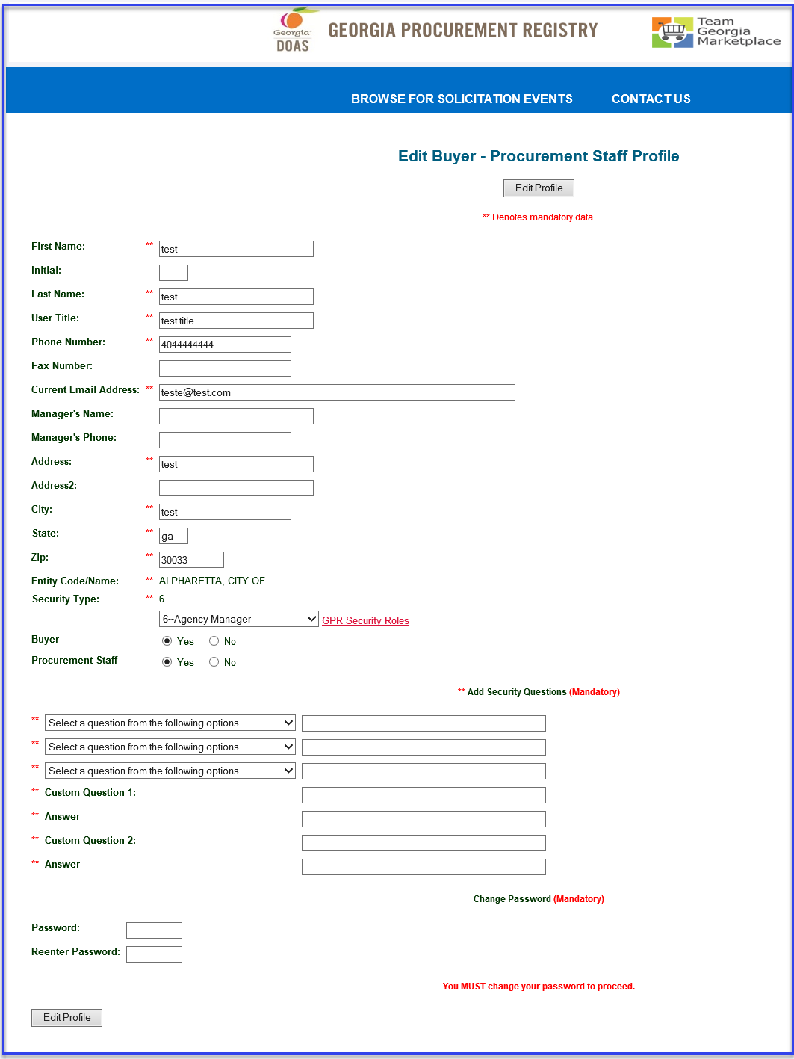
4 | You will have required to fill in security questions and answers. Click on drop down to select question. System will ask you to answer these questions while using ‘Forgot Password?’ functionality of GPR.  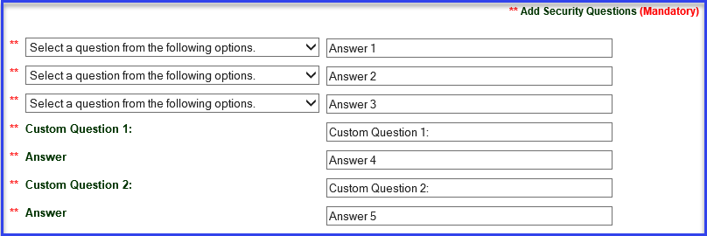
5 | Enter password (your new password must be 6 to 8 characters) and click on ‘Edit Profile’ to save changes.
6 | User will get on screen confirmation of password change and will required to log back in with new password after clicking on ‘Password was changed, Must login with new password.’ button.  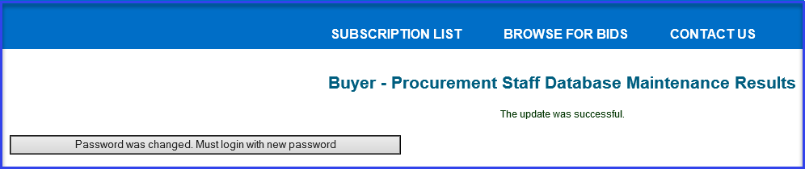
 | End

